SEO Metadata
- Focus Keyword: best website design company in Kolkata
- Meta Title: Best Website Design Company in Kolkata (2026 Guide) | Brewing Ideaz
- Meta Description: Looking for the best website design company in Kolkata? Learn what to evaluate — UX, visual quality, process, pricing & red flags — before you hire.
- URL Slug: /best-website-design-company-in-kolkata

Secondary Keywords
- website design company in Kolkata
- website designers in Kolkata
- professional website design services Kolkata
- custom website design Kolkata
- responsive website design Kolkata
- website redesign services Kolkata
- UI/UX website design Kolkata
- business website design Kolkata
- ecommerce website design Kolkata
- Brewing Ideaz Kolkata

Internal Linking Suggestions
- /services/ or /website-design/ or /web-design/
- /contact-us/
- /portfolio/ or /case-studies/

Best Website Design Company in Kolkata: A Complete Guide to Choosing the Right Partner
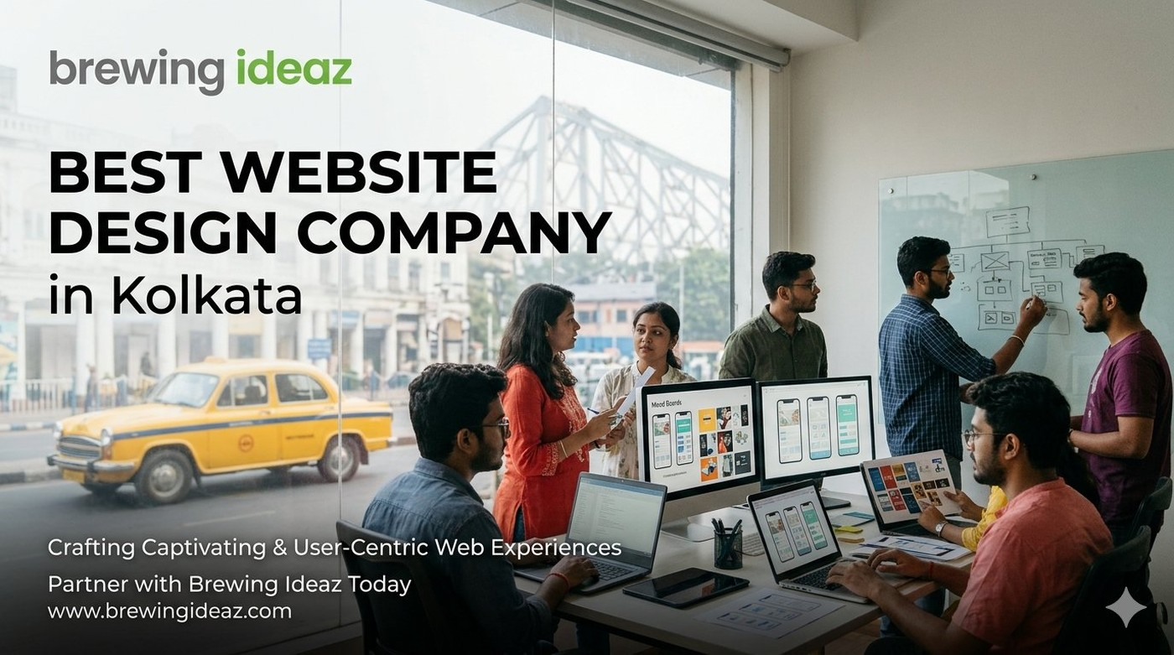
A well-designed website is one of the most important digital assets for any growing business in Kolkata. Many studios claim to be the “best website design company in Kolkata.” The difference between a site that simply looks good and one that actually supports business goals lies in research, process and execution quality. This guide helps you evaluate partners clearly.

What “Best” Means in Website Design
A capable website design company creates experiences that are visually consistent, easy to navigate, fast on mobile and desktop, and aligned with clear business objectives. The strongest partners combine user understanding, information architecture, visual design and practical collaboration with development.
Fit matters. A studio focused on simple brochure sites may not be the right match for a more complex or conversion-focused project.

Key Factors to Evaluate Before Hiring

Live portfolio
Review actual websites. Check mobile experience, clarity and speed.

Research and UX approach
Strong teams ask about users and goals before designing.

Design consistency and scalability
Look for systems thinking rather than one-off pages.

Process transparency
Understand discovery, design phases, feedback loops and hand-off.

Post-launch support
Clarify training and short-term adjustment support.

Ownership
Ensure you receive full design files and rights to the finished website.

Why a Kolkata-Based Website Design Company Can Be an Advantage
Local teams understand the city’s market context, share working hours, and often have experience with both traditional businesses and newer digital brands.

Questions to Ask Before You Hire
- Can you describe your discovery and design process?
- Do you have live examples similar to my project?
- How do you work with developers or handle implementation?
- What timeline and revision process should I expect?
- What support is available after launch?

Red Flags to Watch For
Avoid companies that show only static designs, promise unrealistic timelines, cannot explain their process, or price far below market without clear scope.

Final Thoughts
The best website design company in Kolkata for your business is the one that understands your users and goals, designs with both aesthetics and usability in mind, and delivers a site you can maintain and improve.

Ready to Discuss Your Website Project?
Brewing Ideaz has a branch office in Kolkata (Bangur Avenue) and corporate office in Bengaluru.
Call or WhatsApp: (+91) 62915 47048 Email: info@brewingideaz.com

30 Frequently Asked Questions About Website Design Company in Kolkata
- What is a website design company? A website design company creates and designs websites based on a business’s goals, target audience, and requirements. Services may include visual design, UX, responsive layouts, and development.
- How do I choose the best website design company in Kolkata? Evaluate the company’s portfolio, design expertise, technical capabilities, project process, pricing, communication, and post-launch support.
- What services does a website design company provide? Website design, responsive design, UI/UX design, website redesign, landing page design, and website development.
- How much does a website design company in Kolkata charge? Pricing depends on complexity, features, design requirements, technology, and project scope.
- Why should I hire a professional website design company? To create a website aligned with your business goals that provides a consistent user experience across devices.
- What is the difference between website design and web development? Website design focuses on layout, visual appearance, and UX. Web development implements the design and builds the functionality.
- What is UI/UX design? UI design focuses on visual and interactive elements. UX design focuses on usability, navigation, and user needs.
- Why is responsive website design important? It allows a website to adapt to different screen sizes and devices.
- What is website redesign? Updating a website’s appearance, structure, UX, or functionality to better meet current needs.
- How long does it take to design a website? Depends on complexity, pages, features, content readiness, feedback, and testing.
- What should I prepare before hiring a website design company? Business goals, target audience, requirements, branding assets, content, budget, and timeline.
- What is a website wireframe? A simplified visual layout showing page structure, content placement, navigation, and key elements.
- What is a website prototype? An interactive or visual representation of a website demonstrating user flows before final development.
- What is the role of user experience in website design? How easily and effectively visitors can navigate and complete their intended tasks.
- Why is website loading speed important? A fast-loading website contributes to a better overall user experience.
- What is mobile-friendly website design? Design that ensures usability on smartphones, with readable text and accessible navigation.
- What is accessibility in website design? Designing so people with different abilities can use the site, including keyboard navigation and assistive technologies.
- What is a content management system (CMS)? Software that lets users create, manage, and update content without editing code directly.
- What is the difference between a custom website and a template-based website? A custom site is built to specific requirements; a template site uses a pre-designed layout with limited customisation.
- What is website maintenance? Ongoing updates, backups, security checks, bug fixes, and content updates.
- Will I own my website after the project is completed? Depends on the contract — clarify ownership of code, design files, content, domain, and third-party assets.
- What is included in a website design project? Discovery, wireframes, visual design, responsive layouts, development, testing, launch, and training, depending on scope.
- How do I evaluate a website design company’s portfolio? Review live websites, mobile usability, visual consistency, navigation, performance, accessibility, and relevance.
- Can a website design company help with SEO? Yes — SEO-friendly structures, responsive layouts, and clear navigation; ongoing SEO may require separate services.
- What is conversion-focused website design? Design aimed at helping visitors complete desired actions, such as submitting a form or making a purchase.
- What is the importance of website navigation? Clear navigation helps visitors find relevant information with less effort.
- What should I include in a website design contract? Scope, deliverables, timelines, fees, payment terms, revision limits, ownership, and post-launch support.
- What are common mistakes to avoid when hiring a website design company? Choosing solely on price, ignoring mobile usability, failing to define scope, overlooking ownership terms, neglecting post-launch support.
- Does a website design company guarantee website performance? A company may agree to specific technical requirements, but actual performance also depends on hosting, content, and integrations.
- How can I contact Brewing Ideaz for website design services in Kolkata? Call or WhatsApp +91 62915 47048 or email info@brewingideaz.com.

